**Ideation Phase**

**Define the Problem Statements**

| Date | 31 January 2025 |
| --- | --- |
| Team ID | NM2025TMID05567 |
| Project Name | OPTIMIZING USERS, GROUPS, AND ROLE MANAGEMENT WITH ACCESS CONTROL AND WORKFLOWS |
| Maximum Marks | 2 Marks |

**Customer Problem Statement Template:**

Create a problem statement to understand your customer's point of view. The Customer Problem Statement template helps you focus on what matters to create experiences people will love.

A well-articulated customer problem statement allows you and your team to find the ideal solution for the challenges your customers face. Throughout the process, you’ll also be able to empathize with your customers, which helps you better understand how they perceive your product or service.

Reference: <https://miro.com/templates/customer-problem-statement/>

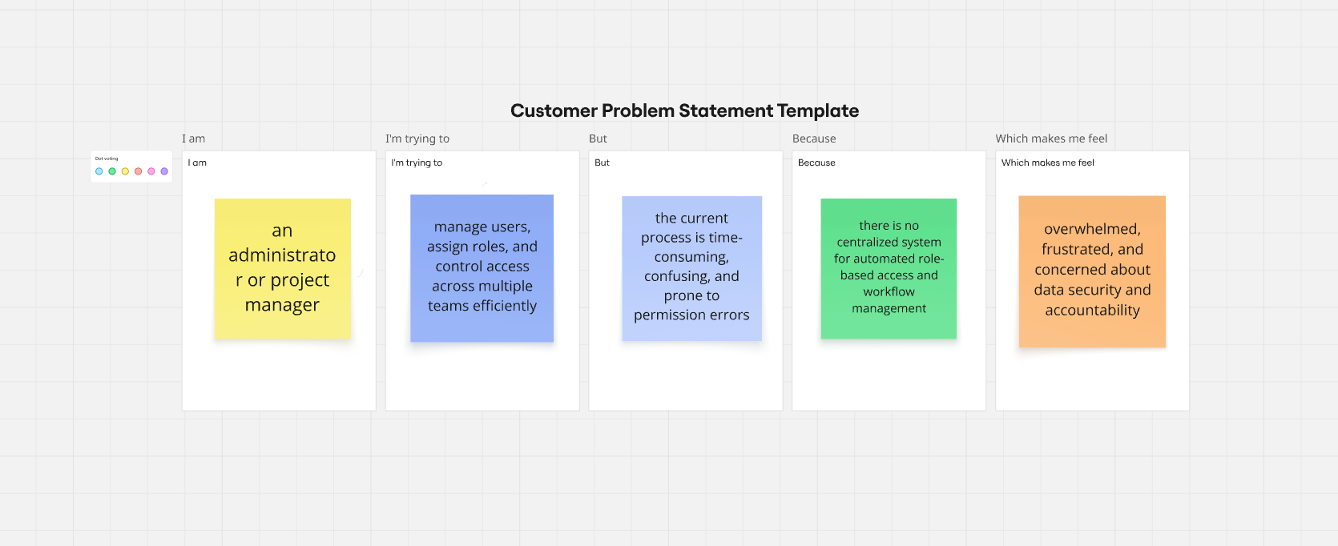

| **Problem Statement (PS)** | **I am (Customer)** | **I’m trying to** | **But** | **Because** | **Which makes me feel** |
| --- | --- | --- | --- | --- | --- |
| PS-1 | A **system administrator** | Manage and assign user roles efficiently across multiple departments | It is time-consuming to update and track user roles manually | The existing system lacks automation, clear visibility, and real-time updates | **Frustrated** and **inefficient** |
| PS-2 | A **team leader** | Ensure the right users have appropriate access levels for their tasks | It’s difficult to monitor and verify user permissions regularly | The current role management process is complex and prone to human error | **Concerned** and **stressed** |